HIGHLIGHTS
- Revenues of Rp4.1 Trillion Amid Strategic Rebalancing, with Strong Profitability Improvements Including Loss to Profit Turnaround of Rp8.5 Billion in Net Profit
- NFCX Group Strengthens the Creative Ecosystem of Brightspot SuperMRKT 2025 with Integrated Digital Solutions
- NFCX Group Strengthens Digitalization of Healthcare Services in Bekasi Regency in Collaboration with APKESMI
- NFCX Group Expands Indonesian IP Globally with First K-Drama Adaptation and New Film Production

Revenues of Rp4.1 Trillion Amid Strategic Rebalancing, with Strong Profitability Improvements Including Loss to Profit Turnaround of Rp8.5 Billion in Net Profit
In FY25, PT NFC Indonesia Tbk (“NFCX”) recorded consolidated revenues of Rp4.1 trillion, declining from Rp6.1 trillion in FY24. This reflects a continued rebalancing of the business, particularly within lower-margin activities in the Digital Product Aggregator segment. Digital Cloud Advertising continued to grow, with revenues rising by 58.5% YoY to Rp279.8 billion in FY25 from Rp176.5 billion in FY24, driven by both network expansion and better monetization. Meanwhile, the Clean Energy segment also recorded solid growth, with revenues increasing 35.2% YoY to Rp145.9 billion, supported by ongoing ecosystem expansion and solid B2B deal flow.

These segments helped offset the decline in the core Digital Product Aggregator business and supported overall margin improvement, hence showing better efficiency and a healthier business mix. Gross profit margin improved from 2.1% in FY24 to 3.4% in FY25. Thus, NFCX’s gross profit increased by 7.2% YoY to Rp140.0 billion in FY25 from Rp130.5 billion in FY24.

At the operating level, the Company recorded a turnaround to operating profit of Rp8.5 billion in FY25, compared to a loss of Rp11.2 billion in FY24. This was supported by both higher gross profit and better cost control, with operating expenses declining by 7.2% YoY. At the bottom line, NFCX also delivered a turnaround in net income attributable to owners of the Company, recording Rp5.6 billion in FY25, reversing the loss of Rp70.3 billion in FY24. This improvement was also supported by non-operating factors, particularly a change in other investments, which moved from an unrealized loss of Rp116.8 billion in FY24 to a gain of Rp28.1 billion in FY25.

Overall, NFCX ended the year on a positive note, with stronger profitability and a more balanced business.

Looking ahead to 2026, the Company will focus on:
- Improving revenue quality, by increasing contribution from higher-margin products and reducing reliance on lower-margin, high-volume transactions
- Increasing monetization per user and per point, through better pricing, improved utilization, and more targeted offerings across its ecosystem
- Deploying new technologies to enhance customer engagement, enabling more interactive transactions and opening additional monetization opportunities at the end user’s point of sale
- Maintaining disciplined cost management, particularly in operating expenses, to support continued margin expansion
With these strategies in place, NFCX aims to build on its improved foundation and deliver more sustainable growth in the coming years.

Strengthens the Creative Ecosystem of Brightspot SuperMRKT 2025 with Integrated Digital Solution
NFCX group strengthened its role in Indonesia’s creative industry ecosystem through a strategic collaboration with Brightspot SuperMRKT 2025, one of the country’s largest curated creative markets featuring more than 220 curated brands and targeting over 100,000 visitors. Through this partnership, NFCX group delivered integrated digital media and technology solutions, including Videotron installations, interactive digital screens, and smart retail technology activations designed to enhance visitor engagement and help brands communicate more effectively with their audiences.

This collaboration highlights NFCX group’s commitment to supporting the growth of the creative industry through innovative digital technology, while strengthening its position as a strategic partner for brands and creative communities in delivering more engaging, relevant, and impactful digital experiences.

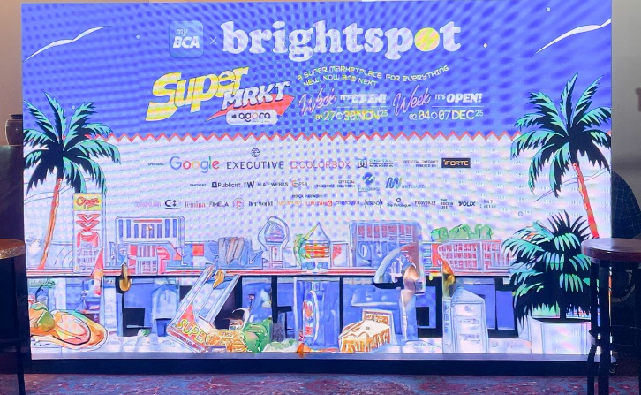

Strengthens Digitalization of Healthcare Services in Bekasi Regency in Collaboration with APKESMI
NFCX group strengthened the digitalization of healthcare services in Bekasi Regency through a Community Activation program in collaboration with Akselerasi Puskesmas Indonesia (APKESMI), attended by 65 heads of community health centers (Puskesmas). During the event, NFCX group introduced its integrated digital hospital and healthcare ecosystem powered by a Cloud Content Management System (CMS), enabling healthcare facilities to manage services and information in a centralized and real-time platform.

NFCX group also showcased supporting technologies including digital signage, patient self-service kiosks, AI Digital Human Assistants, room management systems, and high-resolution medical monitors to improve operational efficiency and patient experience. Collaboration with technology partners such as Fujifilm Indonesia and Tiandy Technologies further strengthened the implementation of digital healthcare solutions covering diagnostics and facility security.



NFCX Group Expands Indonesian IP Globally with First K-Drama Adaptation and New Film Production
NFCX group, through its subsidiary Bumilangit Entertainment, is continuing to grow its content and IP business through both international and local partnerships.

In 2026, the Group will begin production of the K-Drama adaptation of Virgo and the Sparklings in collaboration with HB Entertainment Korea. This project marks the first time an Indonesian IP is adapted into a Korean drama series, bringing local content to a wider global audience. The story is based on a popular webtoon with close to 200 million views worldwide and has been translated into 23 languages, showing strong international appeal.

At the same time, NFCX group is also working with MAGMA Entertainment to produce Si Buta dari Gua Hantu: Mata Malaikat, based on one of Indonesia’s most well-known comic characters. The title has over 180 comic volumes and more than 20 million readers globally. Production is set to begin in 2026, with a planned release in 2027.

Together, these projects show NFCX group’s focus on building strong content IP and expanding its reach beyond Indonesia. By combining international collaborations with well-known local stories, the Group is creating more opportunities for distribution and deeper engagement across its digital platforms.



FINANCIAL SUMMARY

(Expressed in billion Rupiah, unless otherwise stated)
 | FY24 | FY25 | %Chg
Revenue | 6,074.3 | 4,070.0 | (33.0)
Gross Profit | 130.5 | 140.0 | 7.2
EBITDA | 76.6 | 88.8 | 15.8
Operating Profit | (11.2) | 8.5 | N.M.
Net Income* | (70.3) | 5.6 | N.M.
*) attributable to the Owners of the Company

 | 2024 | 2025 | %Chg
Asset | 1,365.9 | 1,376.2 | 0.8
Liabilities | 616.8 | 625.6 | 1.4
Equity | 749.2 | 750.6 | 0.2

Revenue by segment | FY24 | FY25 | %Chg
Digital Product Aggregator | 5,770.3 | 3,644.0 | (36.8)
Digital cloud advertising | 176.5 | 279.8 | 58.5
Clean Energy | 107.9 | 145.9 | 35.2
Digital wholesale | 18.5 | -- | (100.0)
Content & entertainment | 1.0 | 0.3 | (73.3)
Total Revenues | 6,074.3 | 4,070.0 | (33.0)

Further Information, please contact:
Niko Aquino
Vice President of Investor Relations
PT M Cash Integrasi Tbk
Email: nikonaquino@mcash.id
